NodeMCU SMARTPHONE WIFI CONTROL

CAR

Automation or automatic control is the use of various control system for operating any equipment or device such as a remote controlled (toy) car, switching on telephone networks, and other useful applications with minimal or reduced human interventions. This paper proposes a design and implementation of a remote controlled car by wi-fi technology via computer or mobile devices. In completing this research work, wireless software and hardware technologies have been used, such as wireless module of ESP8266 for transceiver (transmitter and receiver), Arduino Uno as microcontroller, an H-bridge L293D IC for motor controller, and two electric DC motors are used to move the automobile. Two objectives of this project are to expand the limitation range of a normal radio frequency car using wi-fi technology and also to create a ubiquitous technology for automobile that operates in daily life with a control system. The test result shows that the controlled car can move in any direction. However, the performance depends on the device signal strength where the maximum testing range is only about 15 meters' distance from the user's location

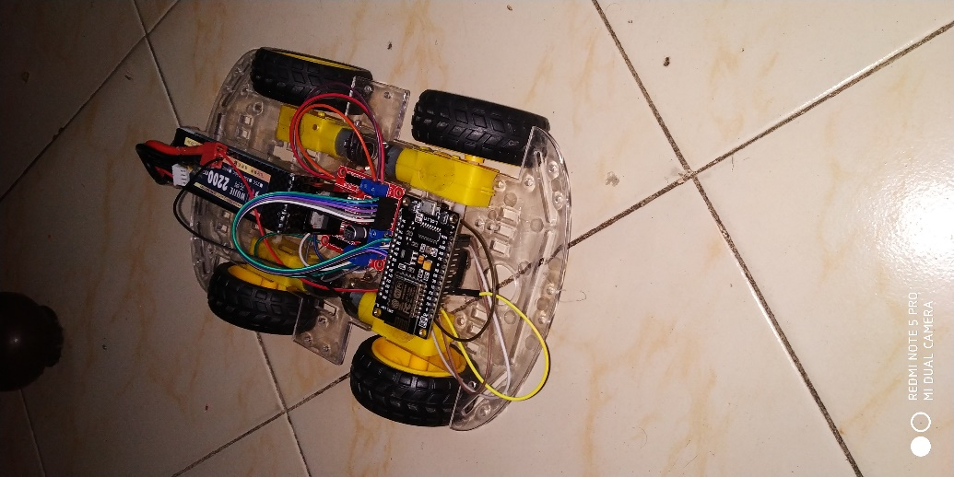`

CIRCUIT DIAGRAM OF NODEMCU CAR

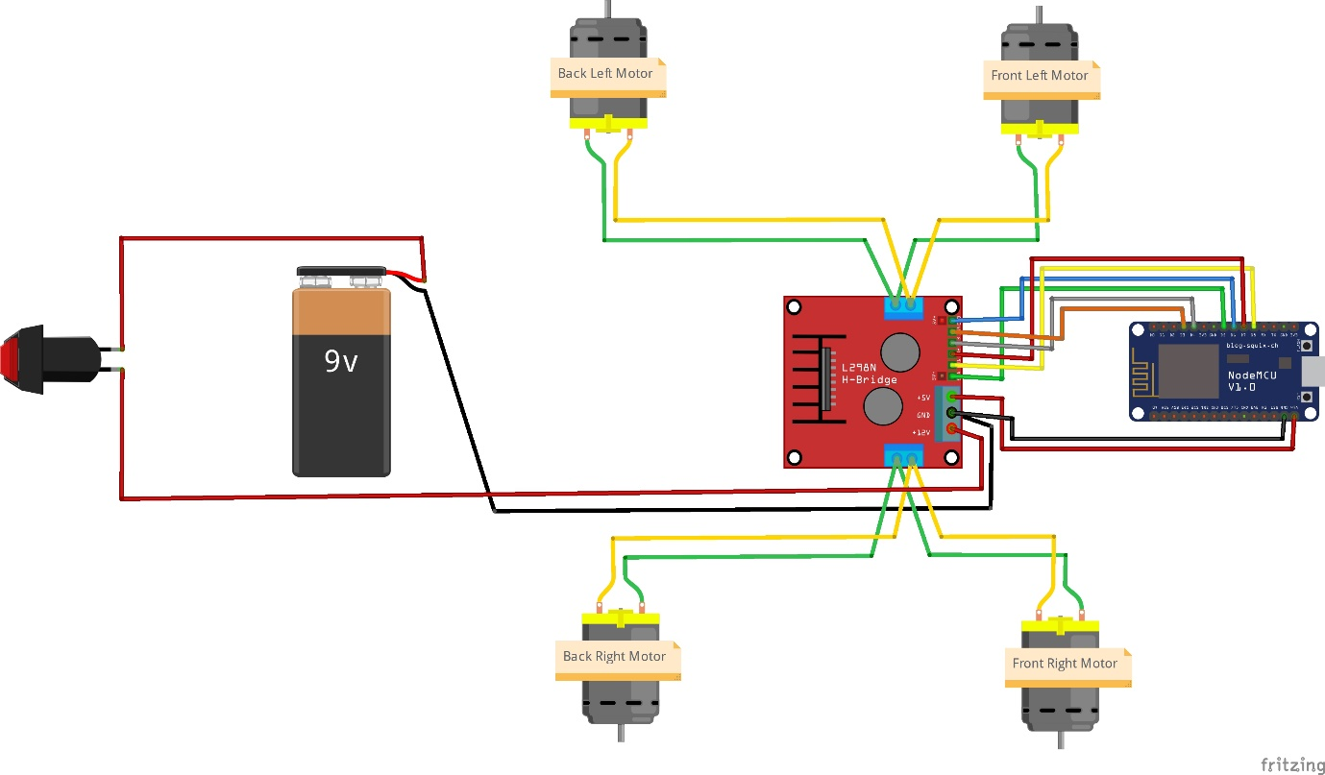

Parts Required :

- NodeMCU (ESP8266MOD)

- Chassis 4WD with DC Motor and Wheel x4

- Motor Driver L298N

- Li-PO Battary (2200)

- MALE-FEMALE WIRES

- FEMALE-MALE WIRES

- SWITCH

* NodeMCU EPS8266MOD

As Arduino.cc began developing new MCU boards based on non-AVR processors like the ARM/SAM MCU and used in the Arduino Due, they needed to modify the Arduino IDE so that it would be relatively easy to change the IDE to support alternate toolchains to allow Arduino C/C++ to be compiled for these new processors. They did this with the introduction of the Board Manager and the SAM Core. A "core" is the collection of software components required by the Board Manager and the Arduino IDE to compile an Arduino C/C++ source file for the target MCU's machine language. Some ESP8266 enthusiasts developed an Arduino core for the ESP8266 WiFi SoC, popularly called the "ESP8266 Core for the Arduino IDE".[16] This has become a leading software development platform for the various ESP8266-based modules and development boards, including NodeMCUs.

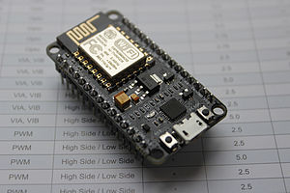

* MOTOR DRIVER (MOTOR CONTROLLER)

[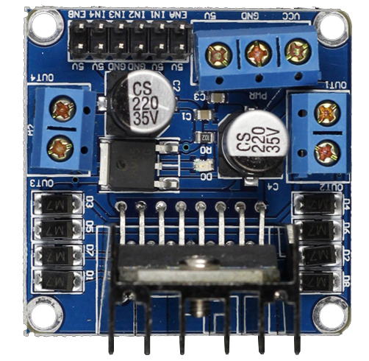](http://wiki.sunfounder.cc/index.php?title=File:Motor1.JPG)  
The L298N is an integrated monolithic circuit in a 15- lead Multiwatt and PowerSO20 packages. It is a high voltage , high current dual full-bridge driver de-signed to accept standard TTL logic level sand drive inductive loads such as relays, solenoids, DC and stepping motors. Two enable inputs are provided to enable or disable the device independently of the in-put signals .The emitters of the lower transistors of each bridge are connected together rand the corresponding external terminal can be used for the connection of an external sensing resistor. An additional Supply input is provided so that the logic works at a lower voltage.  
Its schematic diagram is as shown in figure (a):  
[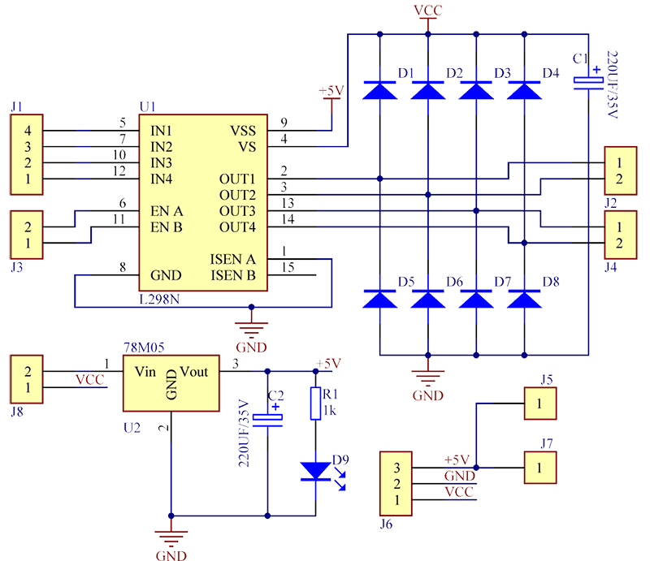](http://wiki.sunfounder.cc/index.php?title=File:Motor2.png)  
(a)Schematic diagram for motor drive module

**Features**

1) High operating voltage, which can be up to 40 volts;  
2) Large output current, the instantaneous peak current can be up to 3A;  
3) With 25W rated power;   
4) Two built in H-bridge, high voltage, large current, full bridge driver, which can be used to drive DC motors, stepper motors, relay coils and other inductive loads.   
5) Using standard logic level signal to control.  
6) Able to drive a two-phase stepper motor or four-phase stepper motor, and two-phase DC motors.  
7) Adopt a high-capacity filter capacitor and a freewheeling diode that protects devices in the circuit from being damaged by the reverse current of an inductive load, enhancing reliability  
8) The module can utilize the built-in stabilivolt tube 78M05 to obtain 5v from the power supply. But to protect the chip of the 78M05 from damage, when the drive voltage is greater than 12v, an external 5v logic supply should be used.   
9) Drive voltage: 5-35V; logic voltage: 5V  
10) PCB size: 4.2 x 4.2 cm

**Pin Function**

[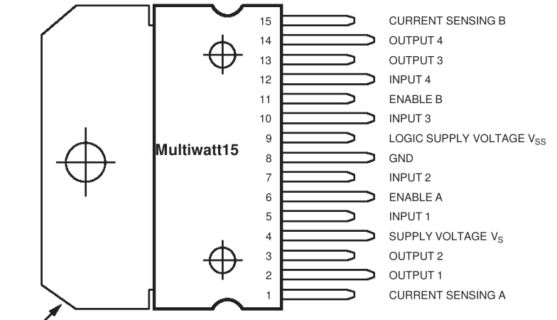](http://wiki.sunfounder.cc/index.php?title=File:Motor3.png)  
Its pin functions are as shown in table (1):  
[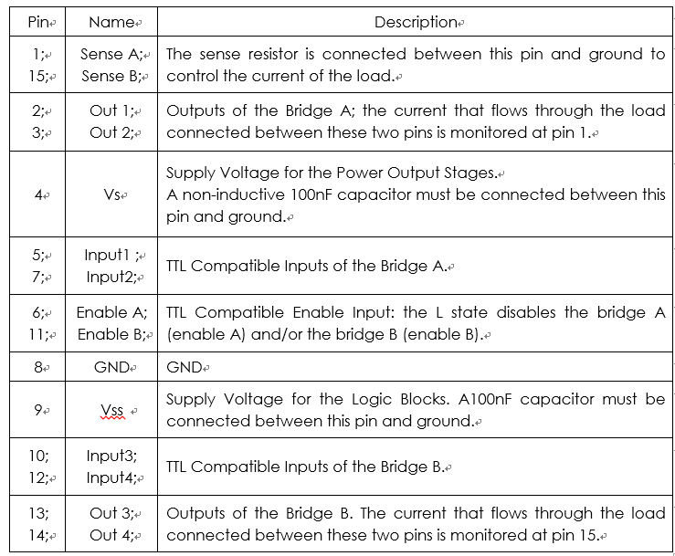](http://wiki.sunfounder.cc/index.php?title=File:Motor4.png)  
(1) Table for L298N pin functions

**Principle**

The driver module can drive two motors. The enabled terminals ENA and ENB are effective at high level. The control mode and state of motor A are as shown in table (2):  
[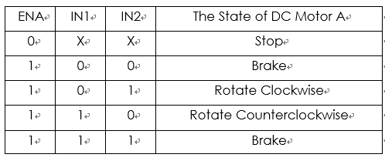](http://wiki.sunfounder.cc/index.php?title=File:Motor5.png)  
(2) Table for control mode and state of motor A  
If you want to regulate the speed of motor A by PWM, you need to set IN1 and IN2, confirm the rotational direction of the motor, and then output PWM pulses for enabled terminals. Please note the motor is in the free stop state when the signal of enabled terminal is 0. When the enabled signal is 1, if IN1 and IN2 are 00 or 11, the motor is in brake state, and the motor stops rotating. If IN1 is 0 and IN2 is 1, the motor A rotates clockwise; if IN1 is 1 and IN2 is 0, the motor A rotates counterclockwise. This is the control method for motor A. The control method for motor B is the same as that for motor A.

**Block Diagram**

[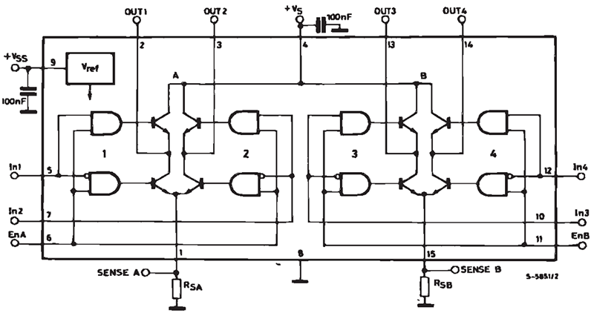](http://wiki.sunfounder.cc/index.php?title=File:Motor6.png)

**Application**

The module can be applied to: - Drive DC motors. Since the module uses a dual H-bridge drive, it can drive two motors at the same time.  
- Drive stepping motors. It can also drive two stepping motors synchronously.